# CS 250 HW1 report1

Complie&Run:

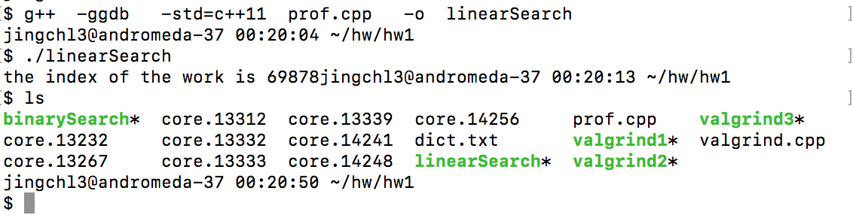

The result of perf stat of binarySearch:

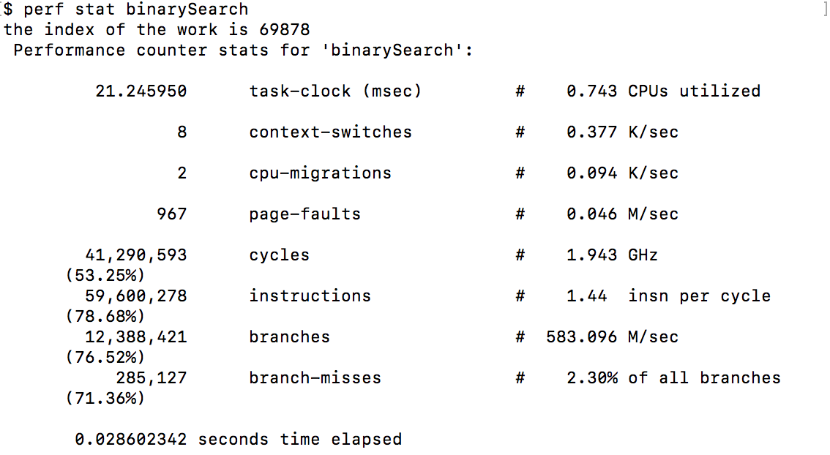

The result of perf stat of linearSearch:

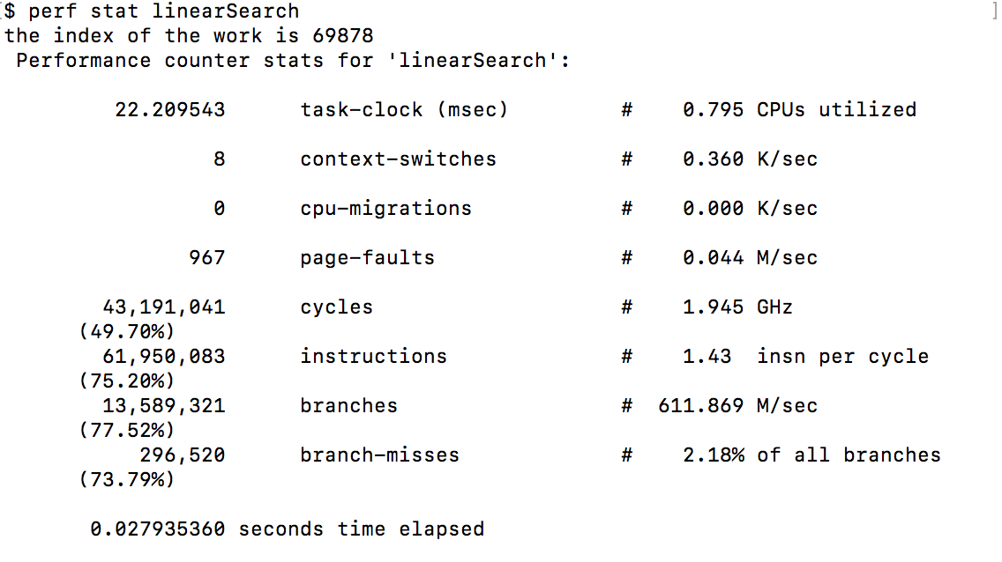

1.Context-Switches.

Context switch is the process to store or restore the state of a process or thread, so that execution can be resumed from the same point at a later time which makes multiple processes can both be executed in the same period of time. But the Context switch will cost resources of computer, so we should avoid high value of context switch.

2.Page Faults.

Major type Page fault is a type of exception that raising when program want to accesses a page that is not in physical memory but in virtual address space. Usually operating system has to interrupt the process and load the page from page’s real address into physical memory space.

The different between Minor type Page fault and major type Page fault is the page is already loaded in memory but is not marked in the memory management unit(MMU); this may happen when other program has already loaded the page in memory.

Invalid type Page fault is the address is not in virtual address space which means there is no page in memory corresponding to it.

3.IPC (Instructions Per Cycle) and its relation to performance.

IPC represents the average number of instructions executed for each clock cycle for a computer. The bigger the IPC is, more likely the computer has better performance.

4.Branch Misses.

The number of failed prediction of branches in this period. Lower value means better performance.